# Chemical Compounds

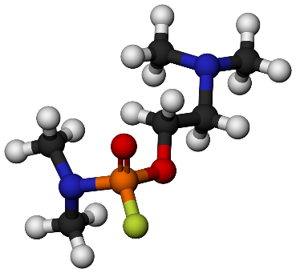

*After you have successfully completed all the needed science courses, you are now ready for your first science task: identifying and separating different chemical compounds*

Write a program that filters different chemical compounds from a **list of elements**. The **first** input **line** will contain the atomic **numbers** of different elements separated by **comma and space** (**", "**). On the next **several lines** you will be given **indices** of elements that form a single compound separated by a **dash**   
(**"-"**). You have to **validate** the indices:

* If the index is **out of range** print: **"Invalid indices"** and **ignore** the line
* If any of the indices is **already included** in another compound print: **"Index {index} is already taken"** and **ignore** the line
* If all the indices are **valid/free** print the formed compound in the format: **"Found compound: {compound_list}"**

When you receive the command **"end"**, stop the program and print the following:

**Total compounds: {total_found_compounds}**

**Elements left: {list_remaining_elements}**

### Input

On the first line you will receive a **list of the elements**

Until the command **"end"** you will get **indices** that form a compound

### Output

Print the output as described above

### Examples

|  |  |
| --- | --- |
| **Input** | **Output** |
| 1, 1, 8, 11, 17, 8, 11, 1, 6, 8, 8, 8  0-7-2  3-4-10  6-1-8-5-9-11  end | Found compound: [1, 1, 8]  Found compound: [11, 17, 8]  Found compound: [11, 1, 6, 8, 8, 8]  Total compounds: 3  Elements left: [] |
| 11, 1, 8, 17, 16, 17, 8, 1  0-5  1-5  20-2  5-2  end | Found compound: [11, 17]  Index 5 already taken  Invalid indices  Index 5 already taken  Total compounds: 1  Elements left: [1, 8, 17, 16, 8, 1] |

*Old chemists never die, they just stop reacting…*